动态文档学习

1. The vibrant community at Stack Overflow http://stackoverflow.com/ and Stack Exchange http://stackexchange.com/ are always very helpful for finding answers to problems that plague any computational researcher.
2. 需要安装的R包：install.packages(c("apsrtable", "brew", "countrycode","devtools", "digest" "formatR", "gdata","ggplot2", "googleVis", "httr", "knitcitations","knitr", "markdown", "openair", "plyr","quantmod", "repmis", "reshape2","RCurl", "rjson", "RJSONIO", "stargazer","texreg", "tools", "treebase","twitteR", "WDI", "XML","xtable", "Zelig"))
3. 贝叶斯所用的包：install.packages("ZeligBayesian",repos = "http://r.iq.harvard.edu/",type = "source")
4. 书籍案例的资料：<http://christophergandrud.github.io/RepResR-RStudio/>.以及<https://github.com/christophergandrud/Rep-Res-Examples>.案例库在：https://github.com/christophergandrud/Rep-Res-ExampleProject1.
5. Makeup language 包括LaTeX以及Markdown——LaTeX安装地址：http://www.latex-project.org/ftp.html. <http://www.latex-project.org/ftp.html>. Markdown有R的安装包（markdown）
6. Markdown 的参数含义

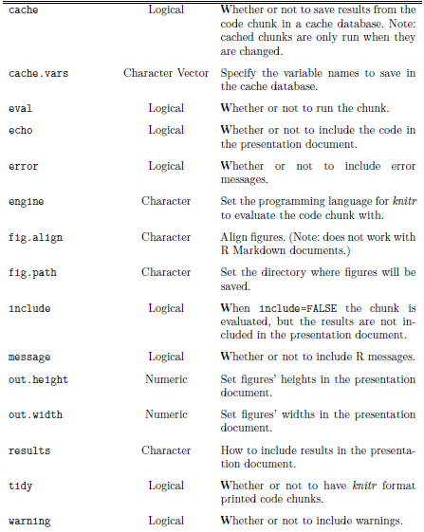

1. 文件（data、Analysis以及presentation）的存储安排

